**Weather Station Build**

This Weather Station is just an example of many possible builds using different materials. Depending on what sensors you choose to incorporate, this build is designed to collect up to 4 types of weather data: temperature, humidity, wind speed and (optionally) barometric pressure. Essentially, there are 4 major components that can be adapted to your design preference:

Container (+fastener), sensors, processor and transmitter.

**Components:**

**Container:**

Purchased or Repurposed  
Any container that is big enough to hold the components AND handle the

<https://www.amazon.com/Containers-Disposable-Insulated-Microwaveable-Dishwasher/dp/B07BLTDD1V>

**+Fasteners**

**Zip ties are the easties**

**Sensors**

Temperature/Humidity sensor

**DHT22**

OR

**BME280** (optional)

Wind Speed

Anemometer

Time (optional)

RTC

**Processor/Transmitter**

ESP32 (Processor AND transmitter

OR

UNO

**Transmitter**

WiFi enabled Microprocessor

Anemometer

DC motor

Optional

**Sensors**

**DHT22**

**BME280**

The BME280 Barometer Module is an easy way to measure barometric pressure, humidity, and temperature readings all without taking up too much space. Basically, anything you need to know about atmospheric conditions you can find out from this tiny breakout. The BME280 Breakout has been designed to be used in indoor/outdoor navigation, weather forecasting, home automation, and even personal health and wellness monitoring.  
  
The on-board BME280 sensor measures atmospheric pressure from 30kPa to 110kPa as well as relative humidity and temperature. The breakout provides a 5V tolerant I2C interface (with pull-up resistors to 3.3V), takes measurements at less than 1mA and idles less than 5µA.

**Features:**

* Operation Voltage: 3.3V
* IIC Communications Interface
* Temp Range: -40℃ to 85℃
* Humidity Range: 0 - 100% RH, =-3% from 20-80%
* Pressure Range: 30,000Pa to 110,000Pa, relative accuracy of 12Pa, absolute accuracy of 100Pa
* Altitude Range: 0 to 30,000 ft (9.2 km), relative accuracy of 3.3 ft (1 m) at sea level, 6.6 (2 m) at 30,000 ft.

**Documents:**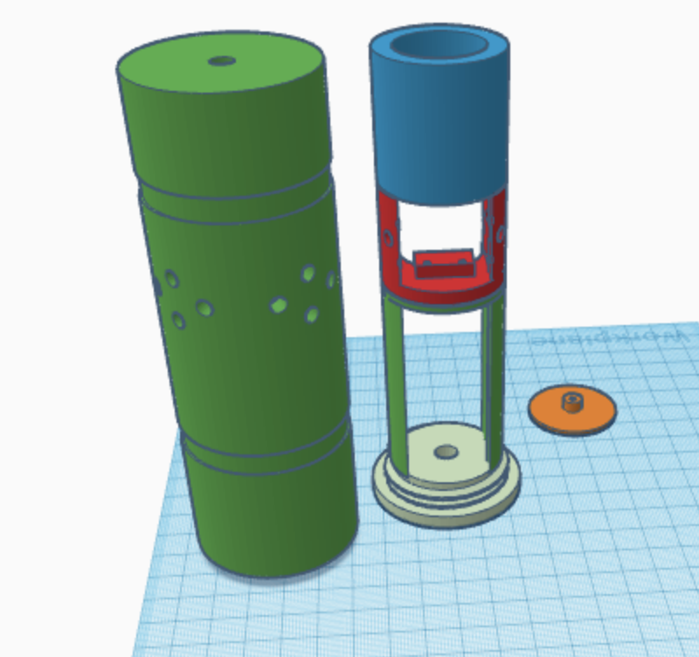

* [Datasheet](https://www.makerfabs.com/desfile/files/BST-BME280_DS001-10.pdf)
* [Arduino Library](https://github.com/sparkfun/SparkFun_BME280_Arduino_Library)

